Rubber band Propeller Car

Subject:  Related Subjects: | Grade Level(s):  Length of Lesson: | Type: Inquiry / Design / Project  Keywords:

Lesson Overview
Use this section to describe at a high level what the lesson is. Should be no more than 3-4 lines.

Lesson Focus
What is the central question or phenomenon being investigated? What problem are they trying to solve?

Lesson Objective(s) | By the end of this lesson, students will…  - Learn the concepts of attraction, repulsion, friction, polarity, and charge.

Lesson Timing

5 minutes | Introduce the Lesson
30 minutes | ...

Materials | - 1-4”cardboard tube  - 2-Clear plastic wheels  - 2-White plastic wheels  - 2-craftsicks  - 2-small paper clips  - 1-large red propeller  - 1-rubber band  - 2-3” thin dowels  - 2-2 ½” straws
Instructor Prep | - Step 1
Related Resources | - List related lessons/ppts etc available from USC or outside, trusted orgs

Lesson Plan

Introduction
Introduce students to the learning goals and make connections to past and present learning experiences. Stimulate interest and prompt students to identify their own questions about the topic. This can link the lesson to real world examples, introduce associated STEM careers, and assess their prior knowledge on the topic.

- Step 1

Procedure
- Make a hole large enough for a straw on one end of the tube
- Make a parallel hole large enough to fit a straw on the other end of the tube
- Insert straws through holes
- Insert dowels through straws
- Poke a small hole in the white plastic wheels small enough for dowel to fit snugly
- Glue the straw in place and the wheels to the dowels
- Glue bead between two craft sticks
- Glue craft sticks on either side of the middle of the tube
- Insert paper clip in the opening near the small
- Cut a 1 ½” piece of the second paper clip
- Bend ¼” of the piece to form a tight V
- Insert the unbent end through the propeller
- Insert the bent end through the bead
- Attach the rubber band to both paper clips

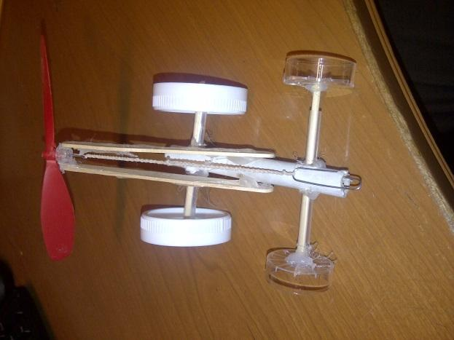

Wrap-up
End the lesson with some final discussions about what students designed/discovered. Connect their activity back to the focus question/problem, real world examples, and STEM careers.

Also include notes about any special cleanup considerations

Lesson Background for Teachers

Suggested Real-World STEM Connections
- List possible related Role Models in STEM (with details and links to more reading). Give suggestions for examples of scientists/engineers who are from underrepresented groups in STEM in related careers.
- List related real-world engineering problems and examples

Lesson Variations and Options
Include descriptions of alternative methods or ways to present things.

Explanation
Describe the background concepts and explanations behind the lesson. This can be more in depth than a teacher/instructor would actually share with students.

Key Concepts and Vocabulary
- Word 1: Grade Appropriate Definition
- Word 2: Grade Appropriate Definition

Safety Notes
- Safety instruction

